PROBLEM SOLVING AND TESTING

NAME : V. Neela devi

VTU: 28598

COURSE CODE:10211CS227

WEEK 1 PROBLEMS
SESSION 1
1.1-Java Lambda Expressions - https://www.hackerrank.com/challenges/java-lambda-expressions/problem
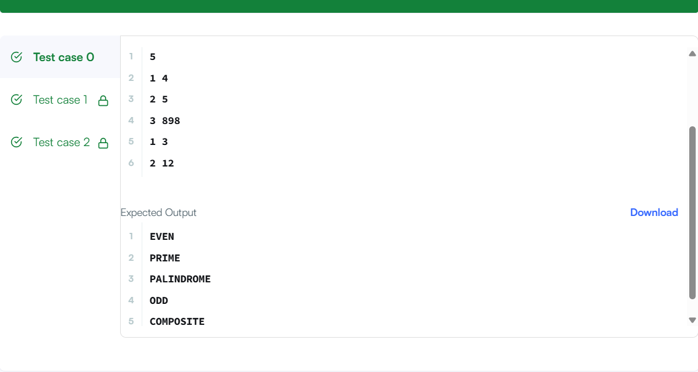
CODE:
import java.io.*;
import java.util.*;
interface PerformOperation {
boolean check(int a);
}
class MyMath {
public static boolean checker(PerformOperation p, int num) {
return p.check(num);
}
public PerformOperation isOdd() {
return n -> n % 2 != 0;
}

public PerformOperation isPrime() {
return n -> {
if (n < 2) return false;
for (int i = 2; i <= Math.sqrt(n); i++) {
if (n % i == 0) return false;
}
return true;
};
}

public PerformOperation isPalindrome() {
return n -> {
String s = Integer.toString(n);
String reversed = new StringBuilder(s).reverse().toString();
return s.equals(reversed);
};
}
} // Closes the MyMath class

public class Solution {

public static void main(String[] args) throws IOException {
MyMath ob = new MyMath();
BufferedReader br = new BufferedReader(new InputStreamReader(System.in));
int T = Integer.parseInt(br.readLine());
PerformOperation op;
boolean ret = false;
String ans = null;
while (T--> 0) {
String s = br.readLine().trim();
StringTokenizer st = new StringTokenizer(s);
int ch = Integer.parseInt(st.nextToken());
int num = Integer.parseInt(st.nextToken());
if (ch == 1) {
op = ob.isOdd();
ret = ob.checker(op, num);
ans = (ret) ? "ODD" : "EVEN";
} else if (ch == 2) {
op = ob.isPrime();
ret = ob.checker(op, num);
ans = (ret) ? "PRIME" : "COMPOSITE";
} else if (ch == 3) {
op = ob.isPalindrome();
ret = ob.checker(op, num);
ans = (ret) ? "PALINDROME" : "NOT PALINDROME";

}
System.out.println(ans);
}
}
}
SESSION 2
2.1 - Java Sort – https://www.hackerrank.com/challenges/java-sort/problem
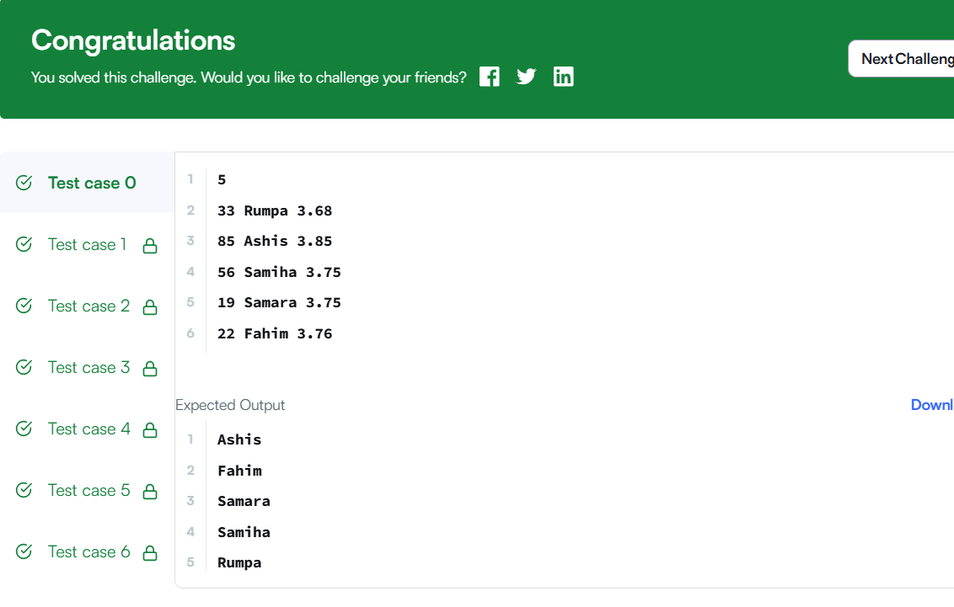
CODE:
import java.util.ArrayList;
import java.util.Comparator;
import java.util.List;
import java.util.Scanner;

class Student {
private int id;
private String firstName;
private double cgpa;

public Student(int id, String firstName, double cgpa) {
this.id = id;
this.firstName = firstName;
this.cgpa = cgpa;
}

public int getId() {
return id;
}

public String getFirstName() {
return firstName;
}

public double getCgpa() {
return cgpa;
}
}

public class Solution {
public static void main(String[] args) {
Scanner in = new Scanner(System.in);
int testCases = Integer.parseInt(in.nextLine());

List<Student> studentList = new ArrayList<Student>();
while (testCases > 0) {
int id = in.nextInt();
String firstName = in.next();
double cgpa = in.nextDouble();

Student st = new Student(id, firstName, cgpa);
studentList.add(st);

testCases--;
}
in.close();

// Java 8 elegant sorting using Comparator chaining
studentList.sort(
Comparator.comparing(Student::getCgpa).reversed()
.thenComparing(Student::getFirstName)
.thenComparing(Student::getId)
);

// Printing names using Java 8 Stream API
studentList.stream()
.map(Student::getFirstName)
.forEach(System.out::println);
}
}
2.2-. Sort Array By Parity https://leetcode.com/problems/sort-array-by-parity/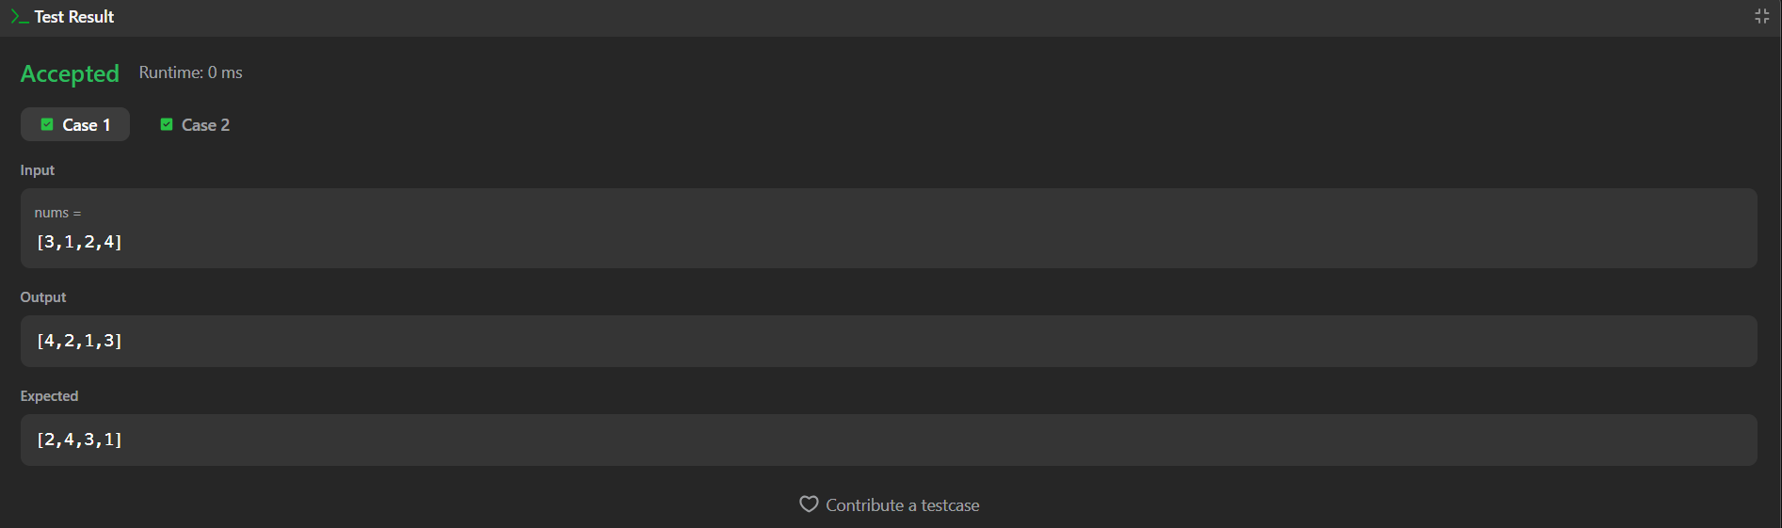
CODE:
class Solution {
public int[] sortArrayByParity(int[] nums) {
int left = 0;
int right = nums.length - 1;

while (left < right) {
// Find an odd number from the left
if (nums[left] % 2 == 0) {
left++;
}
// Find an even number from the right
else if (nums[right] % 2 != 0) {
right--;
}
// Swap if left is odd and right is even
else {
int temp = nums[left];
nums[left] = nums[right];
nums[right] = temp;
left++;
right--;
}
}
return nums;
}
}
SESSION 3
3.1-. Sorting: Comparator – https://www.hackerrank.com/challenges/ctci-comparator-sorting/problem
CODE:
import java.util.*;

class Player {
String name;
int score;

Player(String name, int score) {
this.name = name;
this.score = score;
}
}
class Checker implements Comparator<Player> {
@Override
public int compare(Player a, Player b) {
if (a.score != b.score) {
// Sort descending by score
return Integer.compare(b.score, a.score);
}
// If scores are equal, sort ascending by name alphabetically
return a.name.compareTo(b.name);
}
}

public class Solution {
public static void main(String[] args) {
Scanner scan = new Scanner(System.in);
int n = scan.nextInt();

Player[] player = new Player[n];
Checker checker = new Checker();

for(int i = 0; i < n; i++){
player[i] = new Player(scan.next(), scan.nextInt());
}
scan.close();

Arrays.sort(player, checker);
for(int i = 0; i < player.length; i++){
System.out.printf("%s %s\n", player[i].name, player[i].score);
}
}
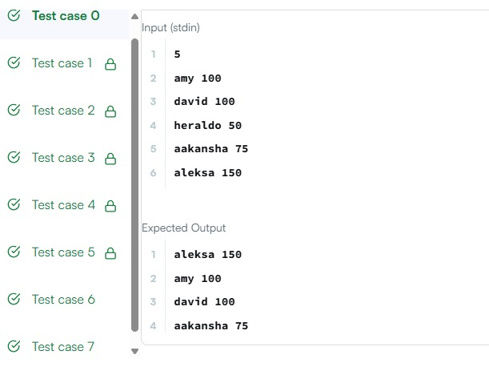

3.2-.Java Comparator – https://www.hackerrank.com/challenges/java-comparator/problem
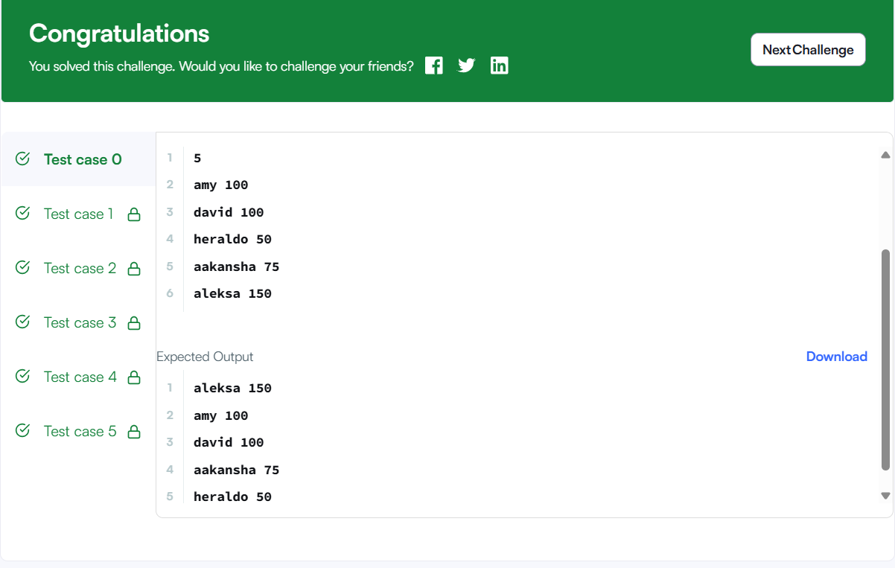
CODE:
import java.util.*;
class Checker implements Comparator<Player> {
@Override
public int compare(Player a, Player b) {
return Comparator.comparingInt((Player p) -> p.score)
.reversed()
.thenComparing(p -> p.name)
.compare(a, b);
}
}
class Player{
String name;
int score;

Player(String name, int score){
this.name = name;
this.score = score;
}
}

class Solution {

public static void main(String[] args) {
Scanner scan = new Scanner(System.in);
int n = scan.nextInt();

Player[] player = new Player[n];
Checker checker = new Checker();

for(int i = 0; i < n; i++){
player[i] = new Player(scan.next(), scan.nextInt());
}
scan.close();

Arrays.sort(player, checker);
for(int i = 0; i < player.length; i++){
System.out.printf("%s %s\n", player[i].name, player[i].score);
}
}
}
SESSION 4
4.1- Running Sum of 1D Array – https://leetcode.com/problems/running-sum-of-1d-array/
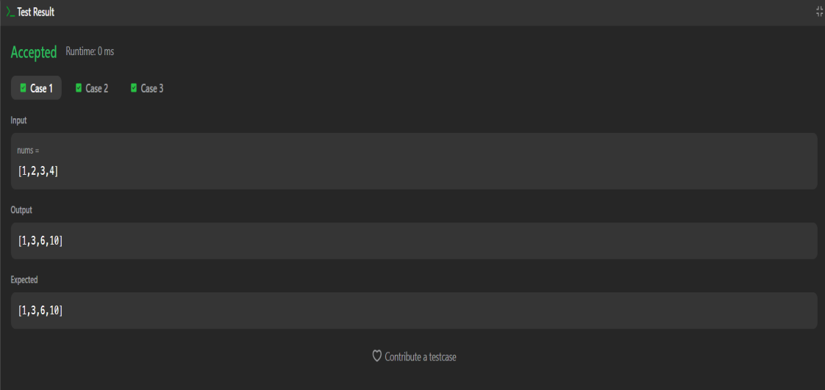
CODE:
import java.util.Arrays;

public class Solution {

public int[] runningSum(int[] nums) {
// Start from index 1 and accumulate the sum in-place
for (int i = 1; i < nums.length; i++) {
nums[i] += nums[i - 1];
}
return nums;
}

public static void main(String[] args) {
Solution solver = new Solution();

// Test Case 1
int[] nums1 = {1, 2, 3, 4};
System.out.println("Input: " + Arrays.toString(nums1));
int[] result1 = solver.runningSum(nums1);
System.out.println("Output: " + Arrays.toString(result1)); // Expected: [1, 3, 6, 10]
System.out.println();

// Test Case 2
int[] nums2 = {3, 1, 2, 10, 1};
System.out.println("Input: " + Arrays.toString(nums2));
int[] result2 = solver.runningSum(nums2);
System.out.println("Output: " + Arrays.toString(result2)); // Expected: [3, 4, 6, 16, 17]
}
}
4.2- Richest Customer Wealth – https://leetcode.com/problems/richest-customer-wealth/
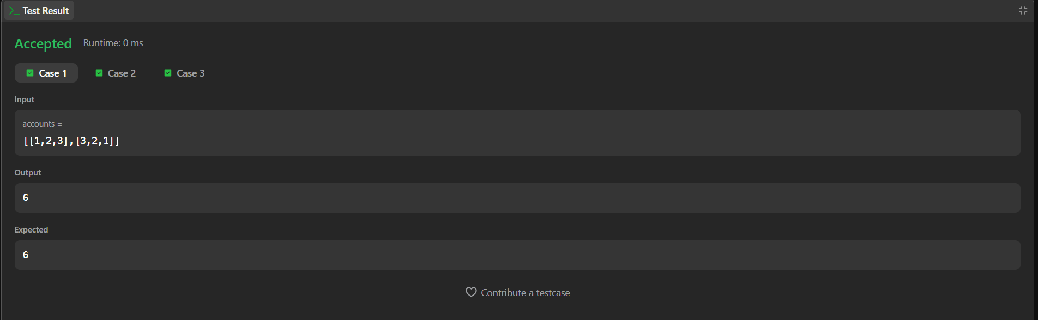
CODE:
import java.util.Arrays;

public class Solution {

public int maximumWealth(int[][] accounts) {
int maxWealth = 0;

// Iterate through each customer
for (int i = 0; i < accounts.length; i++) {
int currentCustomerWealth = 0;

// Sum up all bank accounts for the current customer
for (int j = 0; j < accounts[i].length; j++) {
currentCustomerWealth += accounts[i][j];
}

// Update maxWealth if the current customer is richer
if (currentCustomerWealth > maxWealth) {
maxWealth = currentCustomerWealth;
}
}

return maxWealth;
}

public static void main(String[] args) {
Solution solver = new Solution();

// Test Case 1
int[][] accounts1 = {
{1, 2, 3},
{3, 2, 1}
};
System.out.println("Output 1: " + solver.maximumWealth(accounts1)); // Expected: 6

// Test Case 2
int[][] accounts2 = {
{1, 5},
{7, 3},
{3, 5}
};
System.out.println("Output 2: " + solver.maximumWealth(accounts2)); // Expected: 10

// Test Case 3
int[][] accounts3 = {
{2, 8, 7},
{7, 1, 3},
{1, 9, 5}
};
System.out.println("Output 3: " + solver.maximumWealth(accounts3)); // Expected: 17
}
}

SESSION 5
5.1-Squares of a Sorted Array – https://leetcode.com/problems/squares-of-a-sorted-array/
SESSION 5
5.1-Squares of a Sorted Array – https://leetcode.com/problems/squares-of-a-sorted-array/
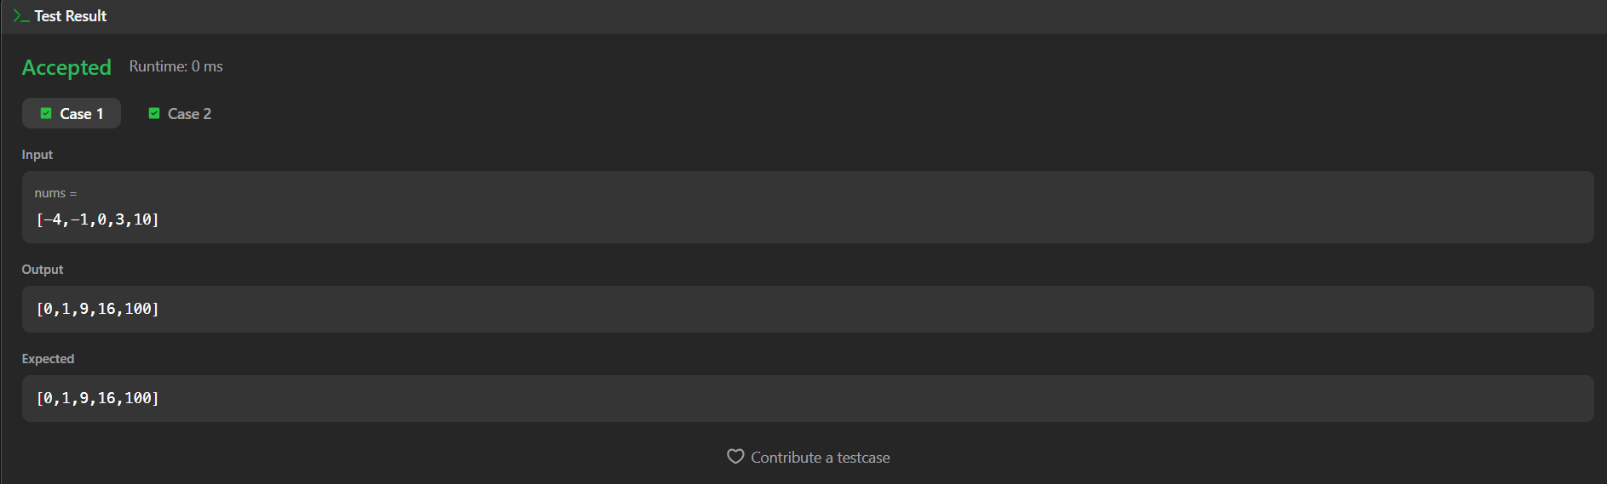
CODE:
import java.util.Arrays;

public class Solution {

public int[] sortedSquares(int[] nums) {
int n = nums.length;
int[] result = new int[n];

int left = 0;
int right = n - 1;
int index = n - 1; // Start filling the result array from the end

while (left <= right) {
int leftSquare = nums[left] * nums[left];
int rightSquare = nums[right] * nums[right];

// Put the larger square at the current end position
if (leftSquare > rightSquare) {
result[index] = leftSquare;
left++;
} else {
result[index] = rightSquare;
right--;
}
index--;
}

return result;
}

public static void main(String[] args) {
Solution solver = new Solution();

// Test Case 1
int[] nums1 = {-4, -1, 0, 3, 10};
System.out.println("Input 1: " + Arrays.toString(nums1));
System.out.println("Output 1: " + Arrays.toString(solver.sortedSquares(nums1)));
// Expected: [0, 1, 9, 16, 100]
System.out.println();

// Test Case 2
int[] nums2 = {-7, -3, 2, 3, 11};
System.out.println("Input 2: " + Arrays.toString(nums2));
System.out.println("Output 2: " + Arrays.toString(solver.sortedSquares(nums2)));
// Expected: [4, 9, 9, 49, 121]
}
}
5.2-Find Pivot Index – https://leetcode.com/problems/find-pivot-index/
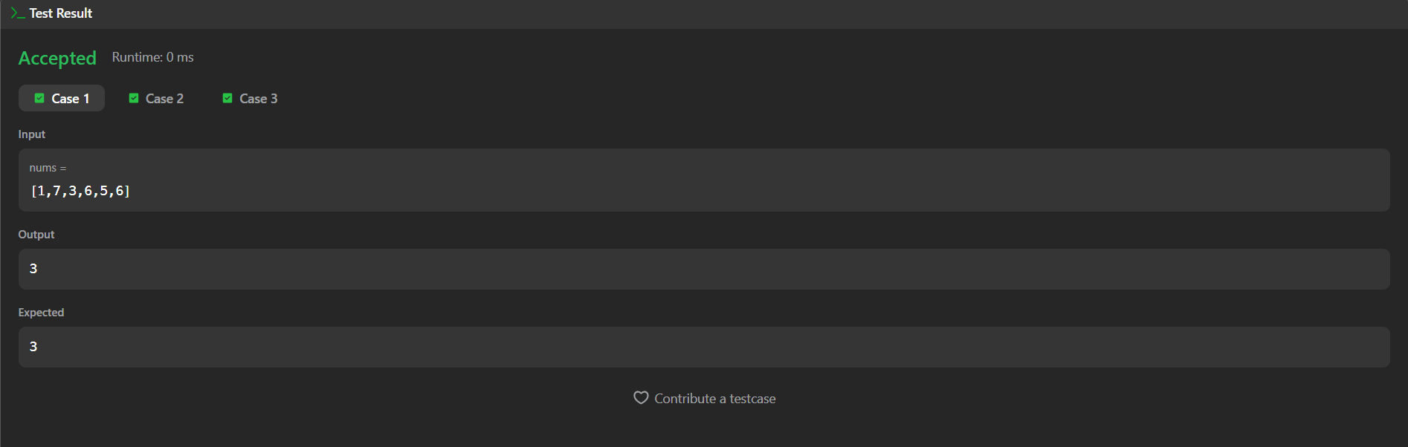
CODE:
import java.util.Arrays;

public class Solution {

public int pivotIndex(int[] nums) {
// Calculate the total sum of all elements in the array
int totalSum = 0;
for (int num : nums) {
totalSum += num;
}

int leftSum = 0;

// Iterate through the array to find the leftmost pivot index
for (int i = 0; i < nums.length; i++) {
// Right sum is totalSum minus leftSum minus the current element
if (leftSum == totalSum - leftSum - nums[i]) {
return i;
}
// Update leftSum for the next index position
leftSum += nums[i];
}

// Return -1 if no pivot index satisfies the condition
return -1;
}

public static void main(String[] args) {
Solution solver = new Solution();

// Test Case 1
int[] nums1 = {1, 7, 3, 6, 5, 6};
System.out.println("Input 1: " + Arrays.toString(nums1));
System.out.println("Output 1: " + solver.pivotIndex(nums1)); // Expected: 3
System.out.println();

// Test Case 2
int[] nums2 = {1, 2, 3};
System.out.println("Input 2: " + Arrays.toString(nums2));
System.out.println("Output 2: " + solver.pivotIndex(nums2)); // Expected: -1
System.out.println();

// Test Case 3
int[] nums3 = {2, 1, -1};
System.out.println("Input 3: " + Arrays.toString(nums3));
System.out.println("Output 3: " + solver.pivotIndex(nums3)); // Expected: 0
}
}

